LAB EXPERIMENT RECORD
SET 19: Survey Responses
Department | AI&DS
Course Code / Course Name | DSA0602 / Data Handling and Visualization
Experiment | Data Visualization using R
Name | Peram Mahitha
Register Number | 192524136
Date | 12 OCTOBER 2026
Day | Tuesday

SET 19: Survey Responses Analysis
Aim:
To visualize survey response distributions for three questions using grouped bar charts, stacked bar charts, and summary tables in R, along with an interactive Tableau dashboard.
Dataset: Survey Responses
Survey ID | Question 1 | Question 2 | Question 3
1 | A | B | C
2 | B | A | D
3 | C | A | B
PROGRAM 1: Grouped Bar Chart
Aim: To visualize the distribution and label the chart elements.
R Program:

graphics.off()

responses <- c(1, 1, 1)
answers <- c("A", "B", "C")

barplot(responses,
names.arg = answers,
col = "skyblue",
main = "Question 1 Response Distribution",
xlab = "Answers",
ylab = "Number of Responses")

text(x = c(0.7, 1.9, 3.1),
y = responses,
labels = responses,
pos = 3)
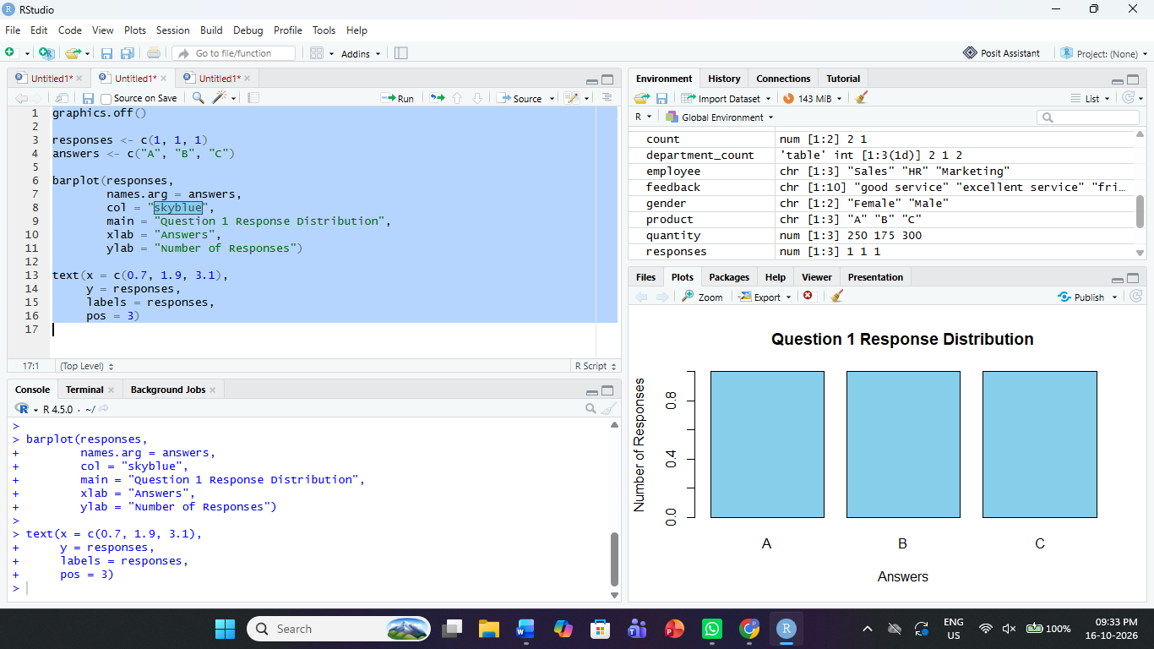
Observation: The chart shows an equal distribution
PROGRAM 2: Stacked Bar Chart (Overall Survey Responses)
Aim: To represent the overall distribution of responses across all three questions using a stacked bar chart.
R Program:

graphics.off()

survey <- matrix(c(
1, 1, 1, 0,
2, 1, 0, 0,
1, 1, 0, 1
), nrow = 3, byrow = TRUE)

rownames(survey) <- c("Question 1", "Question 2", "Question 3")
colnames(survey) <- c("A", "B", "C", "D")

barplot(survey,
col = c("skyblue", "orange", "lightgreen", "pink"),
main = "Overall Survey Responses",
xlab = "Questions",
ylab = "Number of Responses",
legend.text = TRUE)
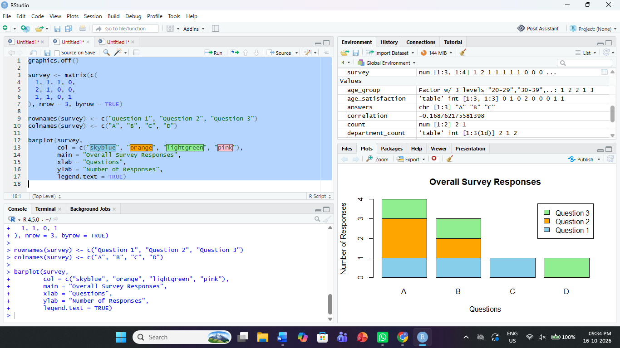
Observation: The stacked bar chart compares answers A, B, C, and D across the three questions. Question 2 has the most responses for answer A.
PROGRAM 3: Survey Response Summary Table
Aim: To build a table showing the survey response data for each survey.
R Program:

survey_data <- data.frame(
SurveyID = c(1, 2, 3),
Question1 = c("A", "B", "C"),
Question2 = c("B", "A", "A"),
Question3 = c("C", "D", "B")
)

print("--- Survey Response Table ---")
print(survey_data)
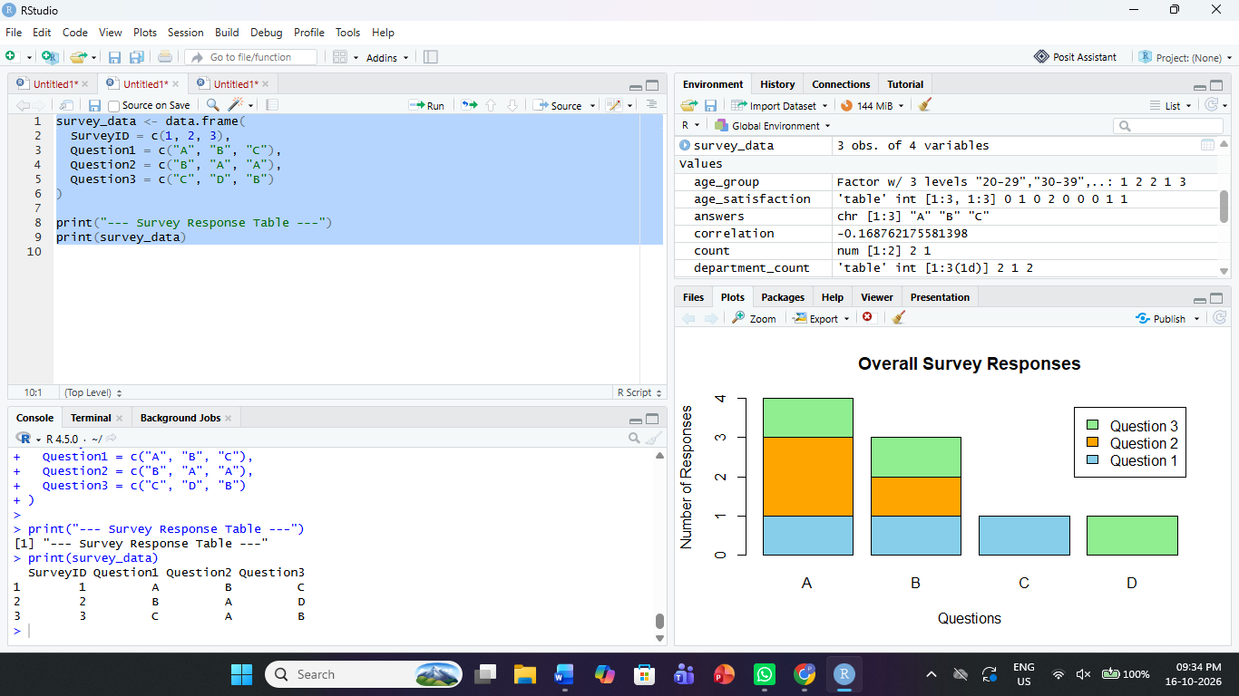
Observation: The table displays the responses of all three surveys for each question. It makes individual survey answers easy to compare.
PROGRAM 4: Survey Responses Dashboard in Tableau
Aim: To create an interactive dashboard combining the grouped bar chart, stacked bar chart, and survey response table.
Steps in Tableau:
- Save the dataset as Survey_Responses.csv and connect it to Tableau.
- Sheet 1 – Question 1 Responses: Use Question 1 and the count of Survey ID to create a bar chart.
- Sheet 2 – Overall Responses: Pivot the Question 1, Question 2, and Question 3 columns into Question and Answer columns. Create a stacked bar chart using Question and Answer.
- Sheet 3 – Survey Response Table: Display Survey ID and all three question responses.
- Create a dashboard and arrange all three sheets.
- Enable Use as Filter for interactive exploration.
Observation: The dashboard displays response distributions and individual survey records. Filtering allows users to explore selected answers and questions.
Procedure:
- Create vectors containing survey responses.
- Use barplot() to display Question 1 responses.
- Use a matrix and barplot() to create the stacked bar chart.
- Create a data frame to display survey records.
- Combine the visualizations in a Tableau dashboard.
Result:
Survey responses were visualized using bar charts and a summary table in R. An interactive survey response dashboard was designed in Tableau.

